UAS Analysis
- Introduction
The UAS system has two transducers: one transmitter (TX) and one receiver (RX). TX is driven by a sine wave (not a square wave) generated by the AD9833 DDS chip. RX picks up the returning ultrasound as a small AC sine-wave voltage, which is then passed through a 26x gain stage and a rectifier + RC envelope detector. This rectifier converts the signal into a digital square wave and it extracts the amplitude of the fast 0.9-2MHz AC oscillation and turn it into a slowly varying analog voltage that the ESP32's ADC can capture the reading. This step is necessary because the amplitude itself is the measurement to correlate with particle size.
Stroke counting: 1 stroke is intended to mean a single push, from either the left or the right side of the syringe. However, in all UAS and microscope data collected so far, "1 stroke" was actually recorded as one full left+right pair. This document should be read as double the labeled value (true stroke count = 2 x labeled stroke count) until the data is relabeled.

- Frequency range significance

A frequency sweep from 0.9 to 2.0MHz (10kHz steps, 111 points) was tested to measure how strongly the transducer actually responds at each frequency. Three datasets were compared: (1) ambient noise, captured with RX active but TX not driving any signal into the fluid -- this is the pure electrical/ADC noise floor; (2) the nipro syringe data, strokes 0-40; and (3) the BD syringe data, strokes 0-40. For each frequency, we computed the "dynamic range" = the maximum voltage minus the minimum voltage seen across all strokes (both syringes combined) to see how much the fluid itself can actually move the reading at that frequency. This dynamic range came out far larger than the ambient electrical noise everywhere in the sweep, confirming it reflects real acoustic response, not noise.
The highest dynamic range reached is 1.7183V, at 1.01MHz (transducer's peak response). Half of that peak is 0.8592V. Using the standard "half-max" used in electronics/acoustics to define a resonance's usable range, any frequency whose dynamic range is $≥0.8592 V$is considered inside the transducer's resonance band. That band is 0.94 to 1.06MHz.
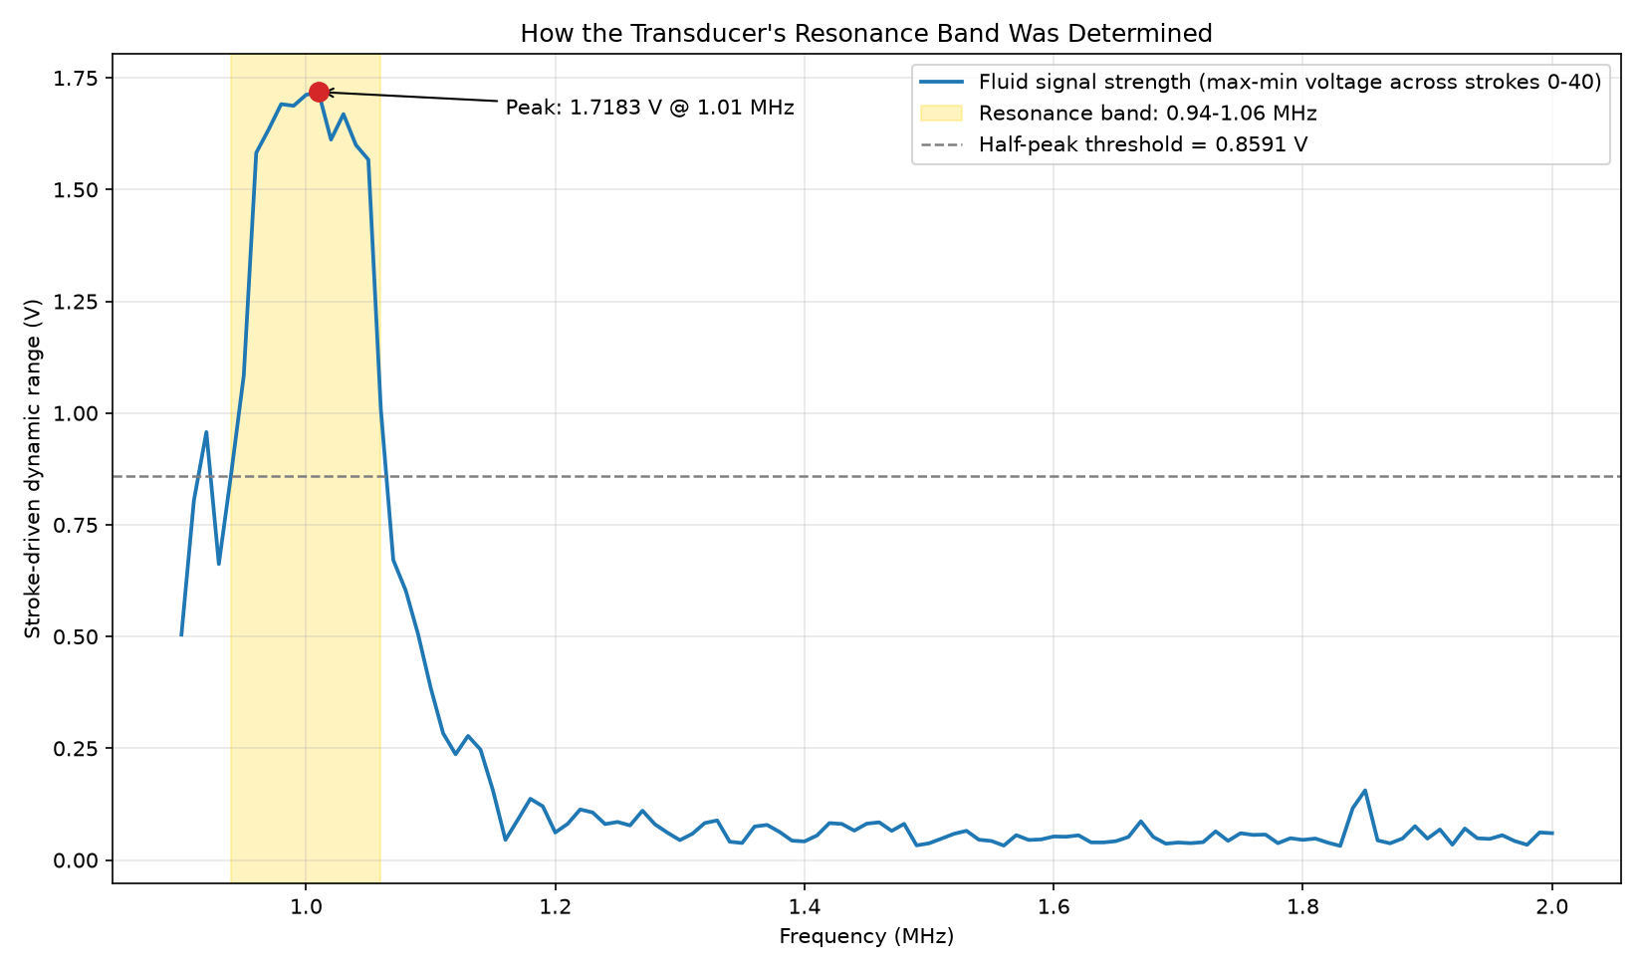
Figure 1. Determining the transducer's resonance band. Blue line = fluid-driven dynamic range (max-min voltage across strokes 0-40, both syringes) at each swept frequency. Peak response is 1.7183V at 1.01MHz; half of that (0.8592V, dashed line) is the resonance threshold. The shaded band (0.94-1.06MHz) is where the response stays at or above that threshold -- the transducer's usable resonance range.
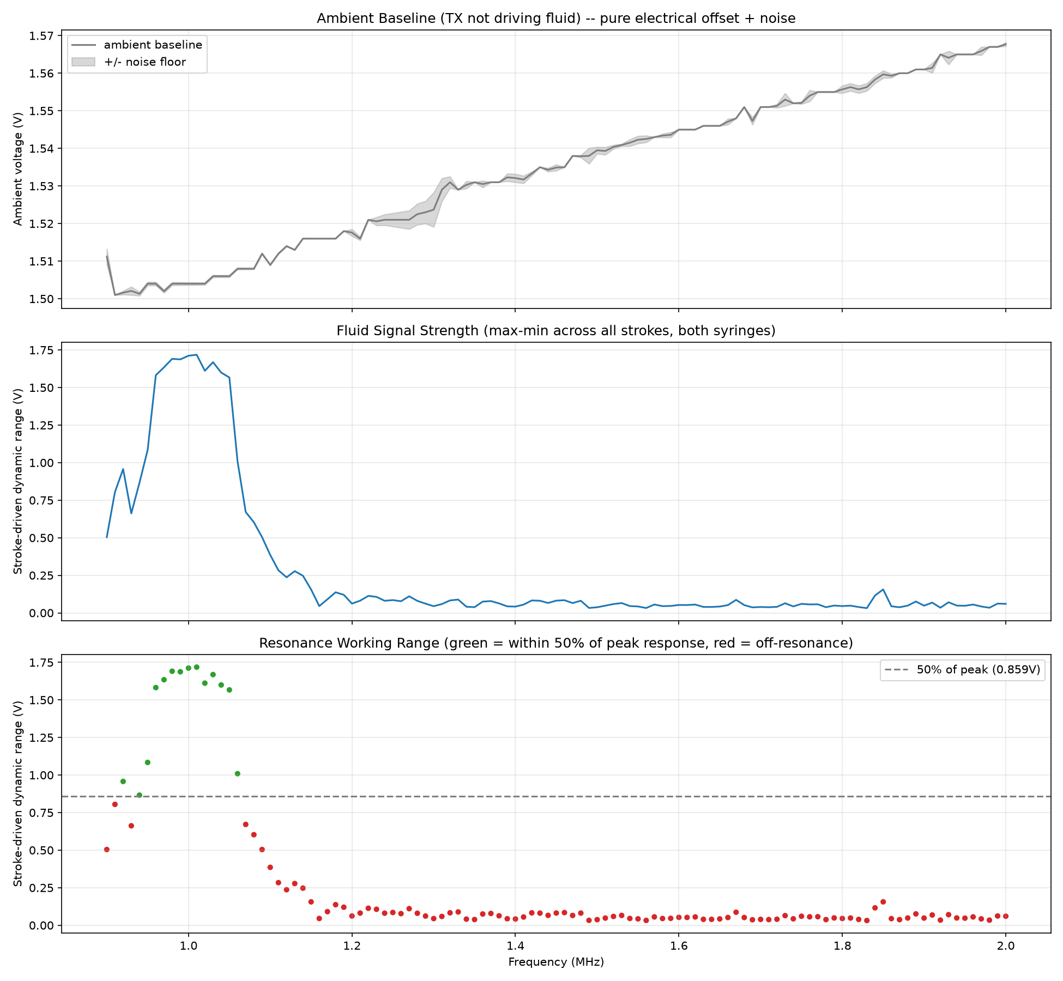
Figure 2. Supporting detail for Figure 1. Top: ambient baseline voltage (TX not driving fluid) with its +/- noise band -- this drifts smoothly and is not related to the resonance peak. Middle: the same fluid-driven dynamic range curve as Figure 1. Bottom: dynamic range again, colored green/red by whether each frequency clears the 50%-of-peak resonance threshold.

- Syringe brand significance
A paired t-test was run at every frequency within the transducer's resonance band, 0.94-1.06MHz (13 frequencies), to check whether syringe brand (BD vs nipro) changes the voltage reading enough to matter. Pairing by stroke count (BD reading at stroke N minus nipro reading at the same stroke N, for all 40 matched strokes) cancels out the large stroke-driven voltage swing and isolates just the syringe-specific offset. For each frequency: mean_diff = average of the 40 paired differences; sd = their standard deviation; t = mean_diff / (sd / sqrt(40)); p-value computed from the t-distribution with 39 degrees of freedom. A frequency is flagged 'significant' if p < 0.05.

Most frequencies in this band came back statistically significant. But with 40 paired stroke measurements, the test is sensitive enough to flag even a tiny, consistent 0.01-0.03V offset as significant. So a second, stricter check was added: a frequency only counts as practically meaningful if it is also significant AND its difference is at least 0.0587V. That 0.0587V cutoff is a typical (median) amount the fluid signal wobbles on its own outside the resonance band, so anything smaller than that can't be trusted as a real syringe effect.

With both checks applied, 5 of the 13 frequencies in the resonance band (38%) show a syringe difference big enough to matter, is concentrated at the band's edges (0.94MHz, 0.97MHz) and its upper end (1.04-1.06MHz), where the difference reaches as high as 0.43V. The middle of the band (0.98-1.03MHz) is syringe safe.

Conclusion: syringe brand matters, and it matters specifically inside the transducer's own resonance band (0.94-1.06MHz) the exact range the sensor needs to operate in. If the final product commits to allow different syringe brand, calibration is needed for this band, particularly at its edges and upper end where the effect is strongest.
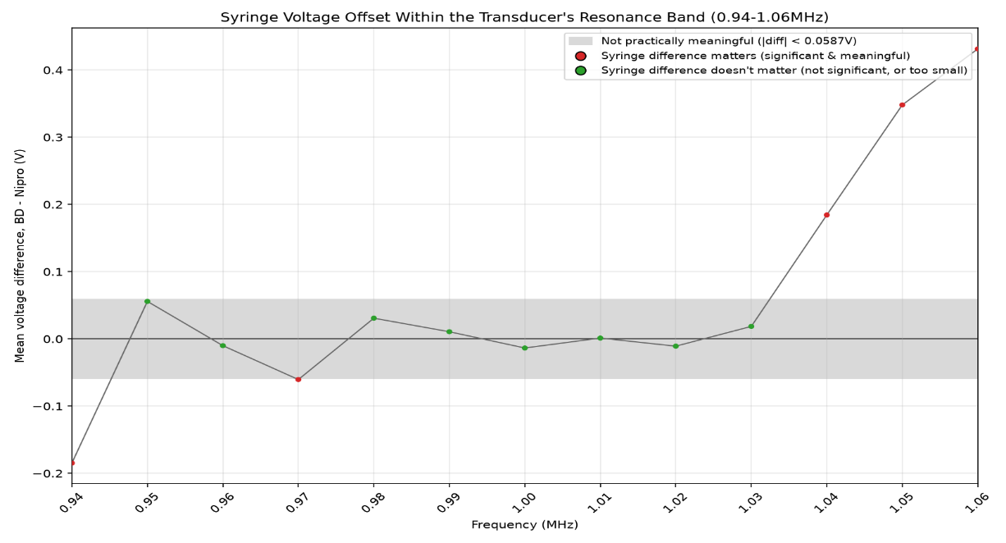
Figure 3. Mean voltage difference (BD - Nipro) across the full sweep. The gray band is the practical-significance threshold (+/-0.0587V);. Red points = the syringe difference is both statistically significant and big enough to matter; green points = it doesn't matter (either not significant, or too small to trust as real).

- Finding the Shape of the Relationship Between Voltage and Particle Size
Does UAS voltage actually track real particle size, or is it just internally consistent without meaning anything physically? CV median particle size (from raw per-particle microscope measurements) was compared against UAS voltage at 0.96MHz -- chosen because it falls inside the transducer's resonance band (0.94-1.06MHz) and stays syringe-safe there -- for strokes 0, 1, 5, 10, 15, 20, 25 (Figures 4 and 5 below show the raw data).
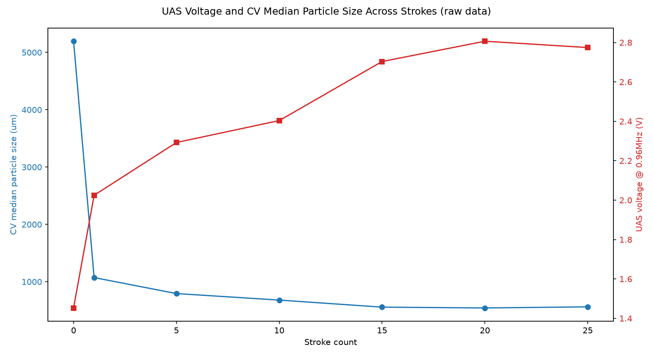
Figure 4. UAS voltage (red, right axis) and CV median particle size (blue, left axis) plotted against stroke count -- the two trends mirror each other.
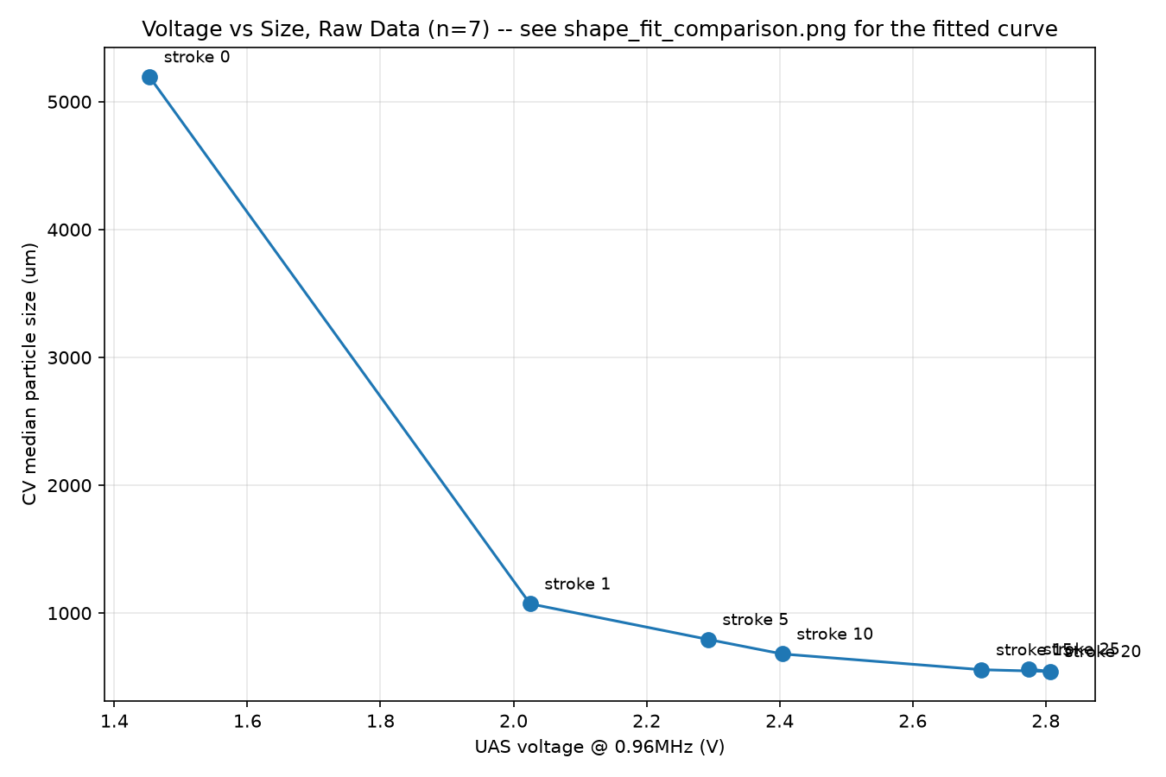
Figure 5. The same data as a direct calibration curve: UAS voltage vs CV median particle size, labeled by stroke count.

Goal: find out whether -- and how -- UAS voltage relates to real particle size, without assuming upfront that the relationship is a straight line. Method: five candidate curve shapes (linear, exponential, power, logarithmic, inverse -- each with 2 fitted parameters, so the comparison is fair) were fit and compared by R2 across three pairings: (1) stroke vs CV size alone, (2) stroke vs UAS voltage alone, and (3) UAS voltage vs CV size directly -- the actual relationship of interest.
Results: size vs stroke best fits an exponential decay (R2=0.885); voltage vs stroke best fits a logarithm (R2=0.953); voltage vs size directly best fits a power law (size = 23423 x voltage^-4.05, R2=0.991). These three are consistent, not contradictory -- an exponentially-decaying quantity plotted against a logarithmically-rising one naturally traces a power-law curve.
Conclusion: yes, there is a real, strong relationship between UAS voltage and particle size -- and it is curved (power law), not linear (R2=0.991 vs 0.754 for a plain linear fit). This also matches the physics: ultrasound scattering scales with particle size raised to a power, not linearly.
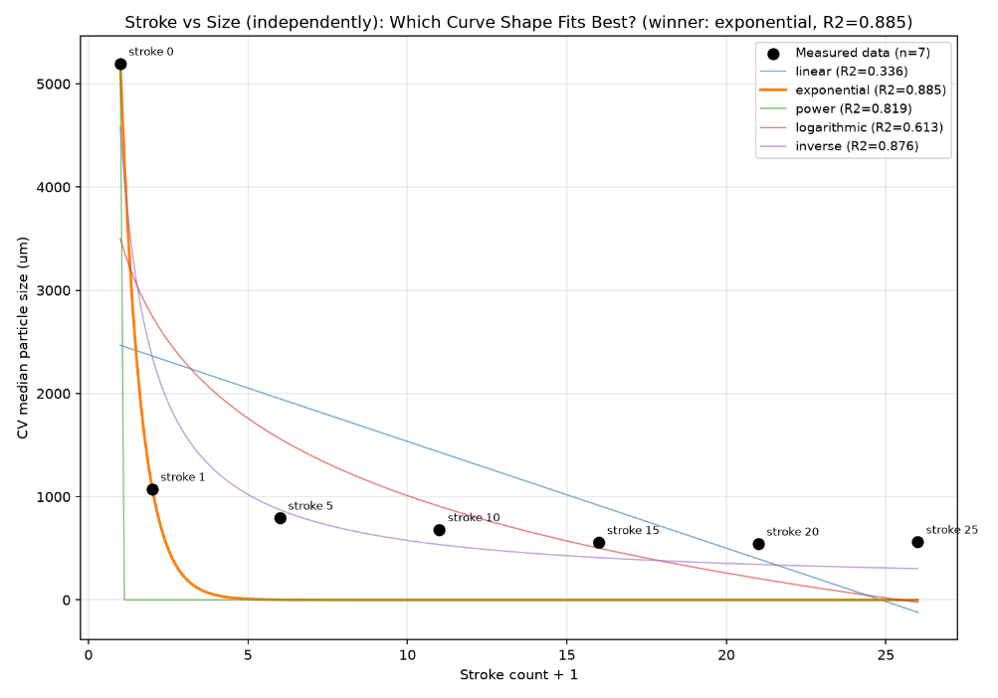
Figure 6. INDIVIDUAL fit: CV median particle size vs stroke count only. Best shape: exponential decay (R2=0.885).
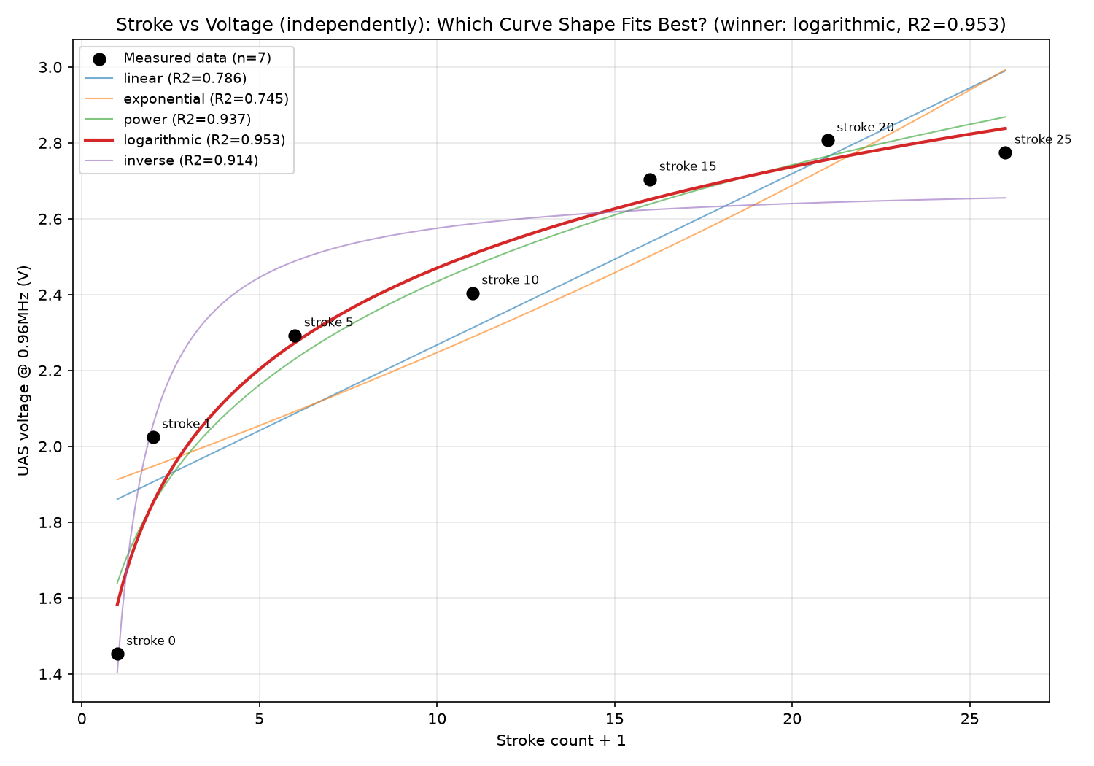
Figure 7. INDIVIDUAL fit: UAS voltage vs stroke count only. Best shape: logarithmic (R2=0.953).
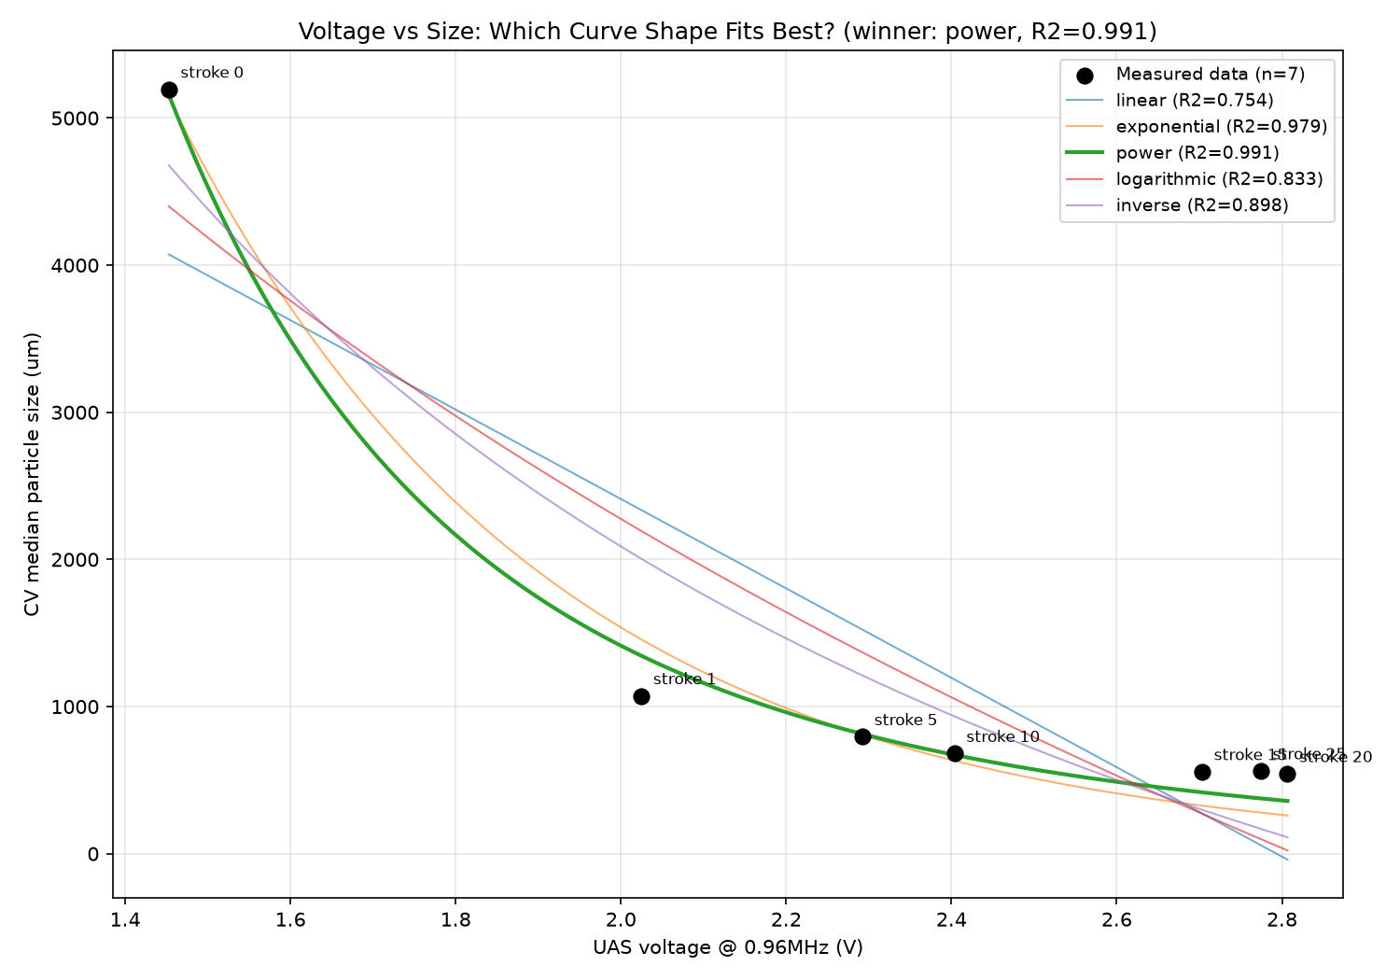
Figure 8. COMBINED fit: UAS voltage vs CV particle size directly (stroke count removed). Best shape: power law (R2=0.991), far better than a plain linear fit (R2=0.754).

